**Photoshop’s Negative Impacts on Society and The Ways of Dealing with It**

Joshua, D. Vandenbor – 500695841

Sean Riddell – 500691642

Trevor Jarvis- #

CPS630 – Web Applications

Group 28

April 20th, 2020

(all members contributed equally to the completion of this assingment)

**Parts A(1-2) and B(1-2):**

**Users**

Users are stored in the mysql database server side. The users table looks like this:

/Users/joshvandenbor/Desktop/Screen Shot 2020-04-20 at 7.46.25 PM.png

The passwords are stored as a hash for added user security.

**Registration**

Registration Is done on the home page by selecting the "Register a user” button in the nav bar. Doing so will take you to the following page:

Here you will simply enter in the information for the user and press submit. If successful, you will be told so in a message and then given a button to return to the homepage. If you are unsuccessful, you will also be told so in a message and then given a button to return to the homepage, at which point you must repeat the process. Adding a user will add a record in the users table in the MySQL database “places”. Passwords will be hashed for security.

**Login**

To login, simply enter in the username and password of the user in the space provided right underneath the nav bar of the home page, then press submit. If successful, you will be sent an html page with a greeting message and a button to return to the homepage. At the homepage you will see a message greeting the user, and a new button to “sign out” that replaces where the login button was before.

**Signout**

If you are already logged in, the homepage will now have a link to sign out right underneath the nav bar.

**admin mode**

To enter admin mode you simply log in to the site using an admin account. Admin mode is fulfilled on the page level by checking the restrictions of a user. The user information of the current user logged in is stored in the session. For example, only admins can access the data base maintenance page. The check is done in the following code:

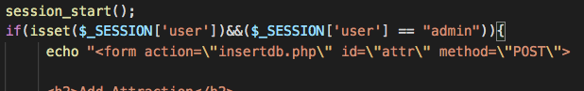

If the if condition is satisfied html code is sent to allow the user to have access to the database controls. ONLY admins have access to the database maintenance section of the site. This is the key difference in their roles.

The same method is used in any scenario requiring a difference in admin and local users.

**Part B-6:**

All major browsers support the application. (Google Chrome, Edge, Firefox).

The layouts are generally consistent to our knowledge, and with the testing we have done.